Name: Prashant Ranjan
Roll No: 24mc3035

Q.1

Program:

#include <iostream>
#include <cstring>
using namespace std;

class A {
public:
char str1[50];
A(const char* s) { strcpy(str1, s); }
};

class B {
public:
char str2[50];
B(const char* s) { strcpy(str2, s); }
};

class C : public A, public B {
public:
char result[100];
C(const char* s1, const char* s2) : A(s1), B(s2) {}
void concat() {
strcpy(result, str1);
strcat(result, str2);
}
void display() {
cout << "Concatenated string: " << result << endl;
}
};

int main() {
C obj("Hello", "World");
obj.concat();
obj.display();
return 0;
}

Output:

Concatenated string: HelloWorld

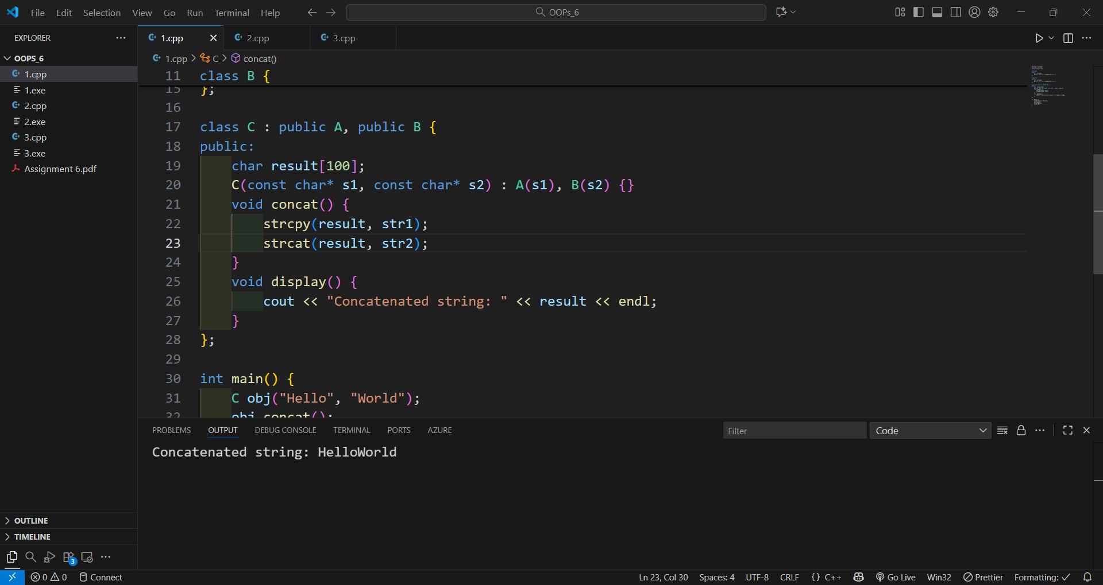

Q.2

Program:

#include <iostream>
using namespace std;

class Vehicle {
public:
string name;
int wheels;
Vehicle(string n, int w) { name = n; wheels = w; }
void display() {
cout << "Vehicle: " << name << ", Wheels: " << wheels << endl;
}
};

class two_wheeler : public Vehicle {
public:
two_wheeler() : Vehicle("Bike", 2) {}
};

class three_wheeler : public Vehicle {
public:
three_wheeler() : Vehicle("Auto Rickshaw", 3) {}
};

class four_wheeler : public Vehicle {
public:
four_wheeler() : Vehicle("Car", 4) {}
};

int main() {
two_wheeler t;
three_wheeler th;
four_wheeler f;
t.display();
th.display();
f.display();
return 0;
}

Output:

Vehicle: Bike, Wheels: 2
Vehicle: Auto Rickshaw, Wheels: 3
Vehicle: Car, Wheels: 4
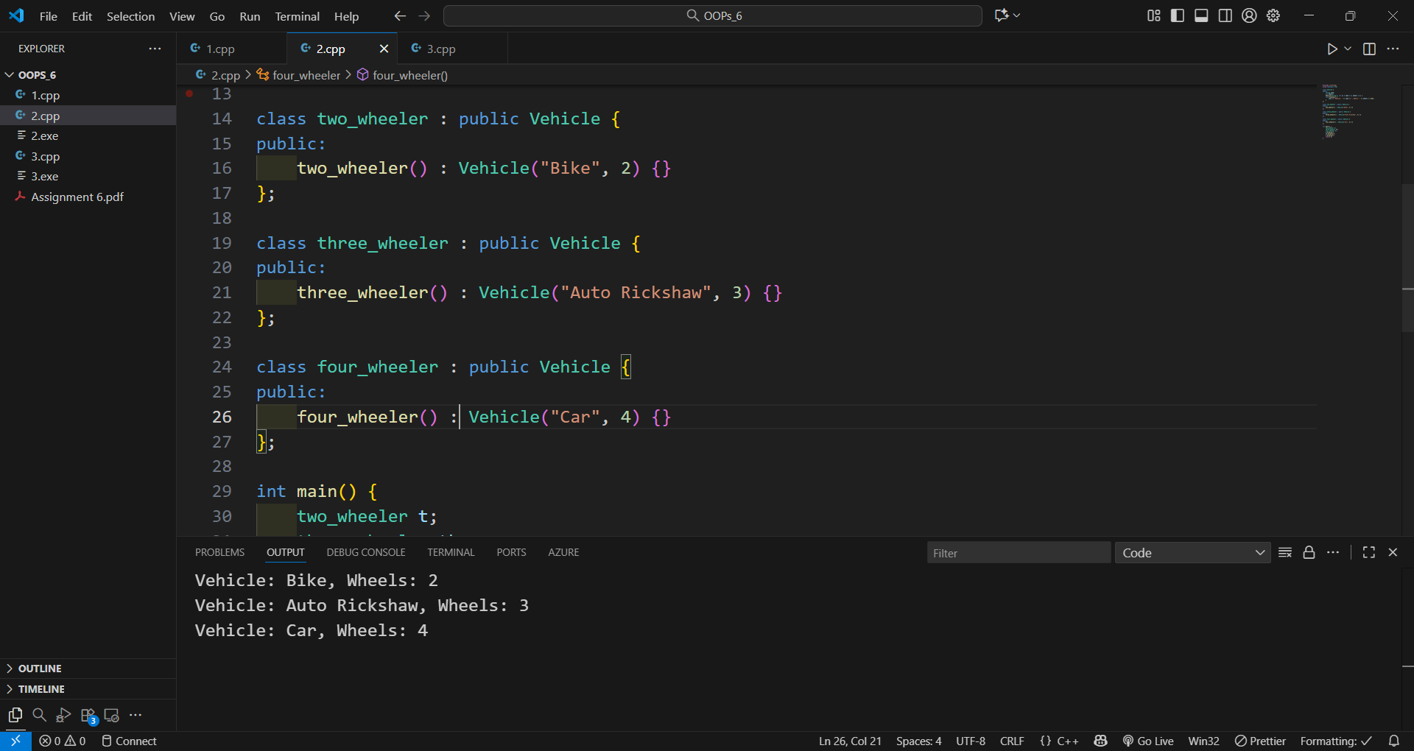

Q.3

Program:

#include <iostream>
using namespace std;

class employee {
public:
string name;
int id;
employee(string n, int i) { name = n; id = i; }
void show() {
cout << "Name: " << name << ", ID: " << id << endl;
}
};

class employee2 : public employee {
public:
double compensation;
enum period { hourly, weekly, monthly } pay_period;
employee2(string n, int i, double c, period p) : employee(n, i) {
compensation = c;
pay_period = p;
}
void display() {
show();
cout << "Compensation: " << compensation << endl;
cout << "Pay Period: ";
if (pay_period == hourly) cout << "Hourly";
else if (pay_period == weekly) cout << "Weekly";
else cout << "Monthly";
cout << endl;
}
};

int main() {
employee2 e("John", 101, 5000.75, employee2::monthly);
e.display();
return 0;
}

Output:

Name: John, ID: 101
Compensation: 5000.75
Pay Period: Monthly

